**What’s For Dinner: One-Pot Taco Casserole**

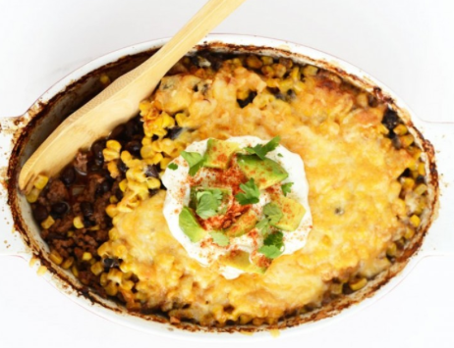

Shopping List:

|  |  |
| --- | --- |
| AMOUNT | ITEM |
| 1 | can spray oil |
| 1 | package ground turkey |
| 1 | package diced onion |
| 1 | jar salsa |
| 1 | package taco seasoning |
| 1 | can of black beans |
| 1 | can of corn |
| 1 | package shredded cheese |
| 1 | tomato (topping) |
| 1 | container sour cream (topping) |