**What’s For Dinner: Barbeque Chicken Casserole**

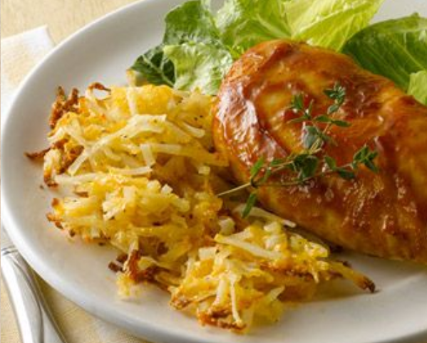

Shopping List:

|  |  |
| --- | --- |
| AMOUNT | ITEM |
| 1 | package diced potatoes w/ onions |
| 1 | cup shredded cheddar cheese |

|  |  |
| --- | --- |
| 4 | Chicken breasts |
| 1 | bottle barbeque sauce (18 oz.) |
| 1 | bottle spray oil |
|  | gloves |