What’s For Dinner: Cheesy Chicken & Rice Casserole
Supporting Materials

Original Recipe:

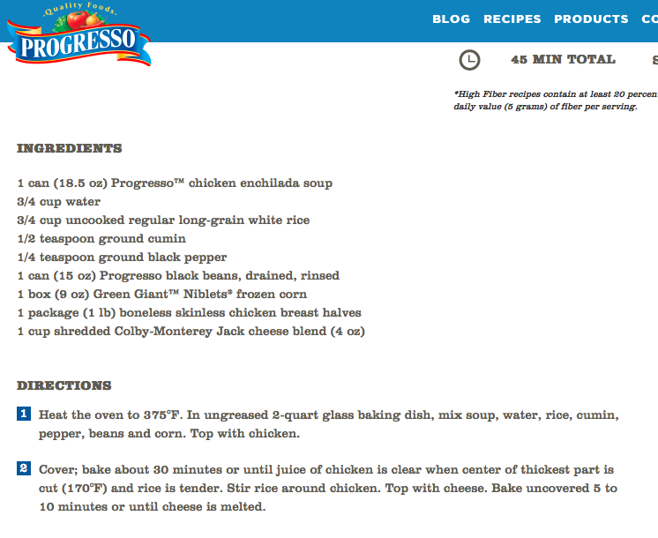

Equipment Needed:

- oven
- small strainer (to strain black beans from can)
- scissors (to open corn)
- 2 quart baking pan
- spoon
- 1 Cup Measuring cup
- Disposable gloves (to handle raw meat)

Notes:

- It is best to buy the cheese already shredded for ease of production. A variety of different cheeses can be used with this recipe.
- Some individuals will have difficulty opening the corn with scissors; this might have to be done for them or with them.
- When possible, choose snap-off cans unless the individual is capable of using a can-opener.
- Note that the rice, black pepper and cumin are combined in the kit version for ease of production.

- Straining the black beans over the sink might be difficult for the individual. It might be helpful to hold the strainer for them while they pour the beans in.
- It is important that gloves be worn while handling raw meat. As soon as the cheese has been spread over the chicken, the gloves should be taken off and thrown away to prevent the spread of any bacteria. Once thrown away, the individual should wash their hands and proceed with the recipe.

- The water content has been adjusted to 1 cup for ease of production; this does not negatively change the outcome.
- As with all recipes in this series, the measuring cups and spoons used are based on a series available from Giant for approximately $3.99:
