What’s For Dinner: Tuna Casserole
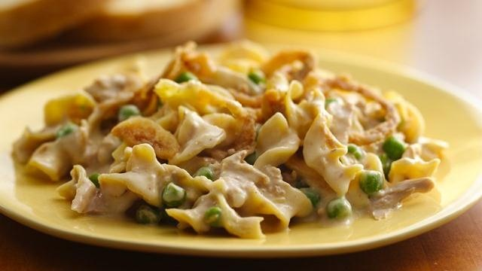
1. Heat oven to 350 degrees. Spray baking pan.
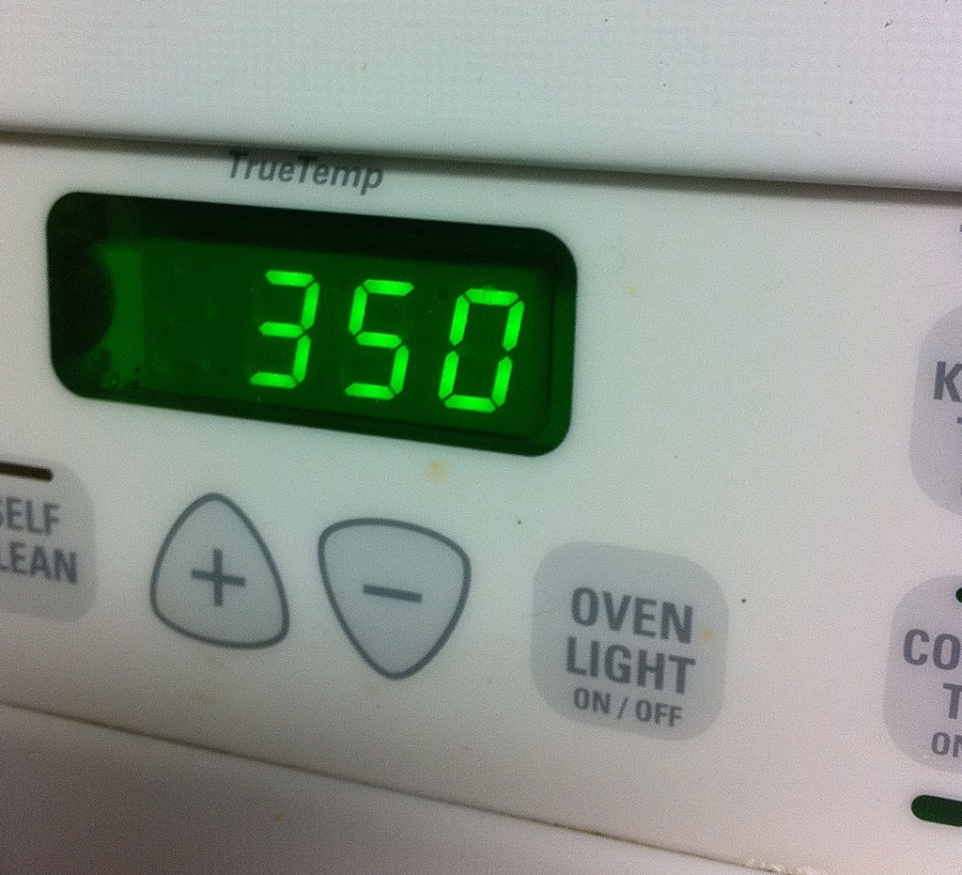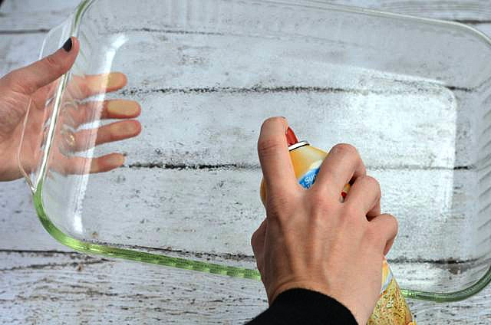
2. Open can of tuna, drain of water and pour tuna into bowl.
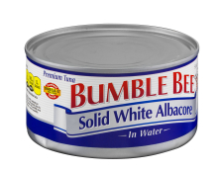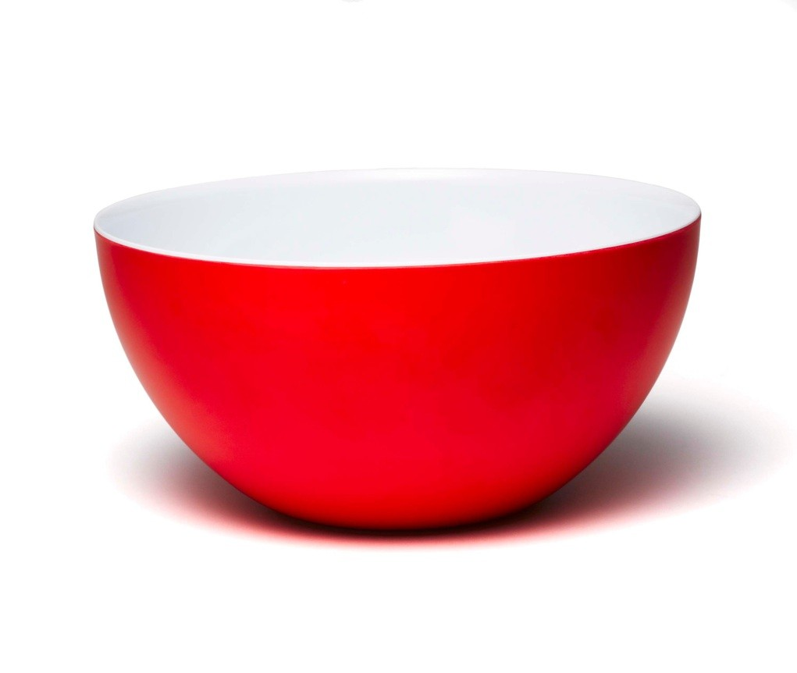
3. Add 3 cups elbow macaroni to bowl.
This is quick cooking pasta and does not need to be boiled.
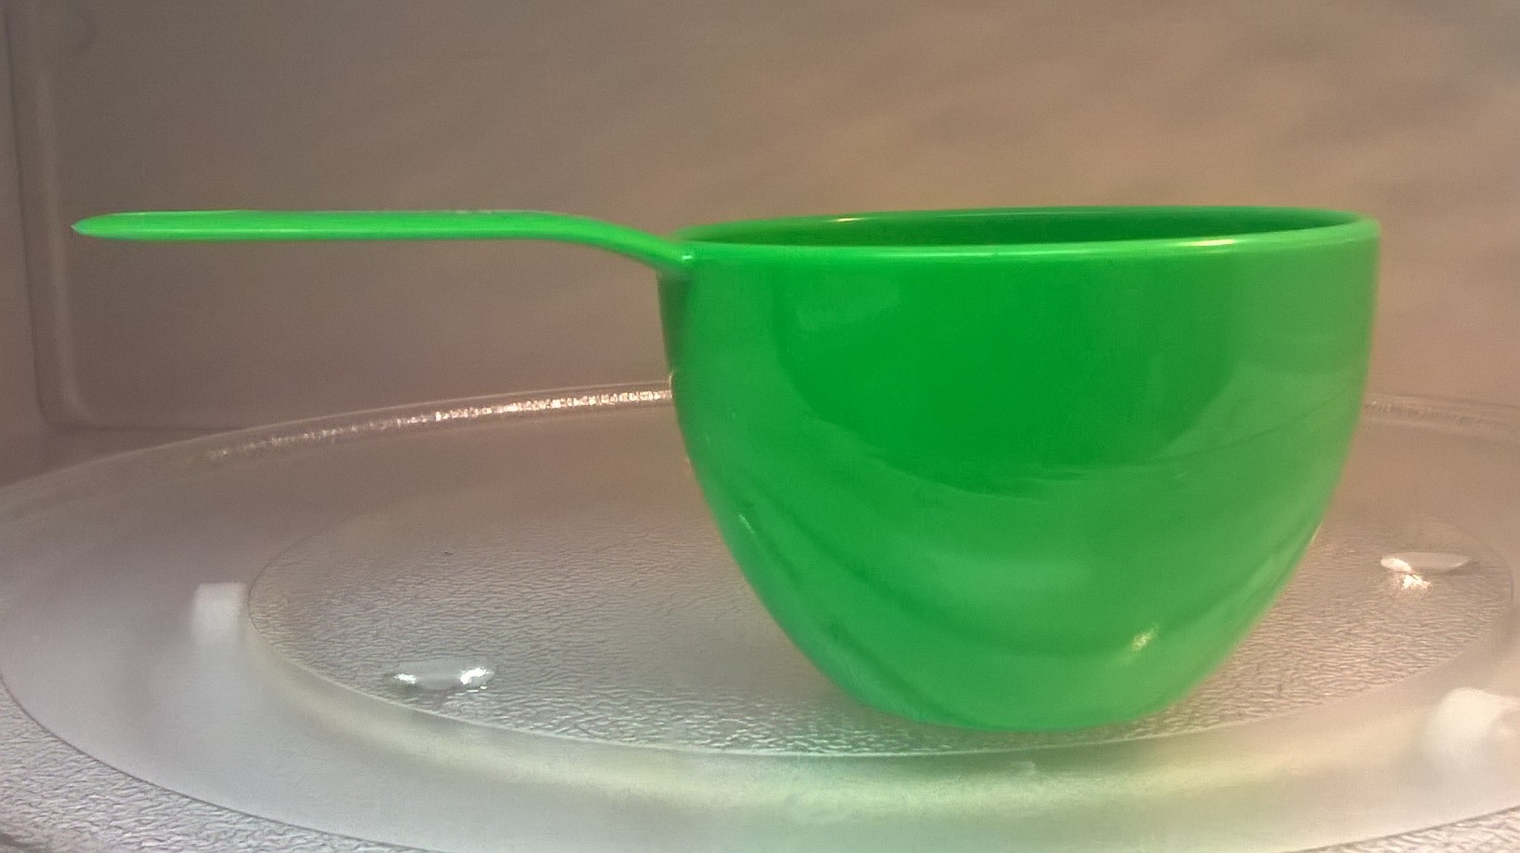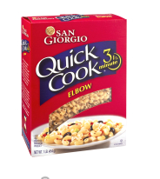
4. Add can of soup and peas to bowl. Mix.
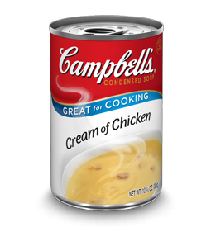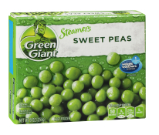

5. Add entire container of milk to the bowl. Stir.
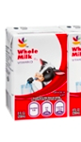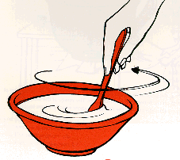

6. Pour the ingredients of bowl into baking pan.
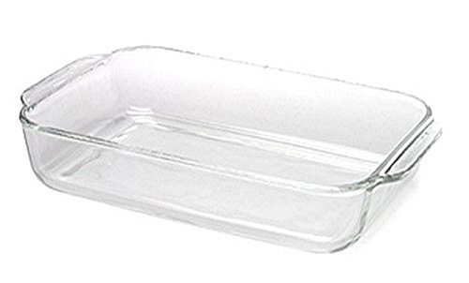
7. Spread cheese over top of pan, then spread crispy fried onions over the cheese.
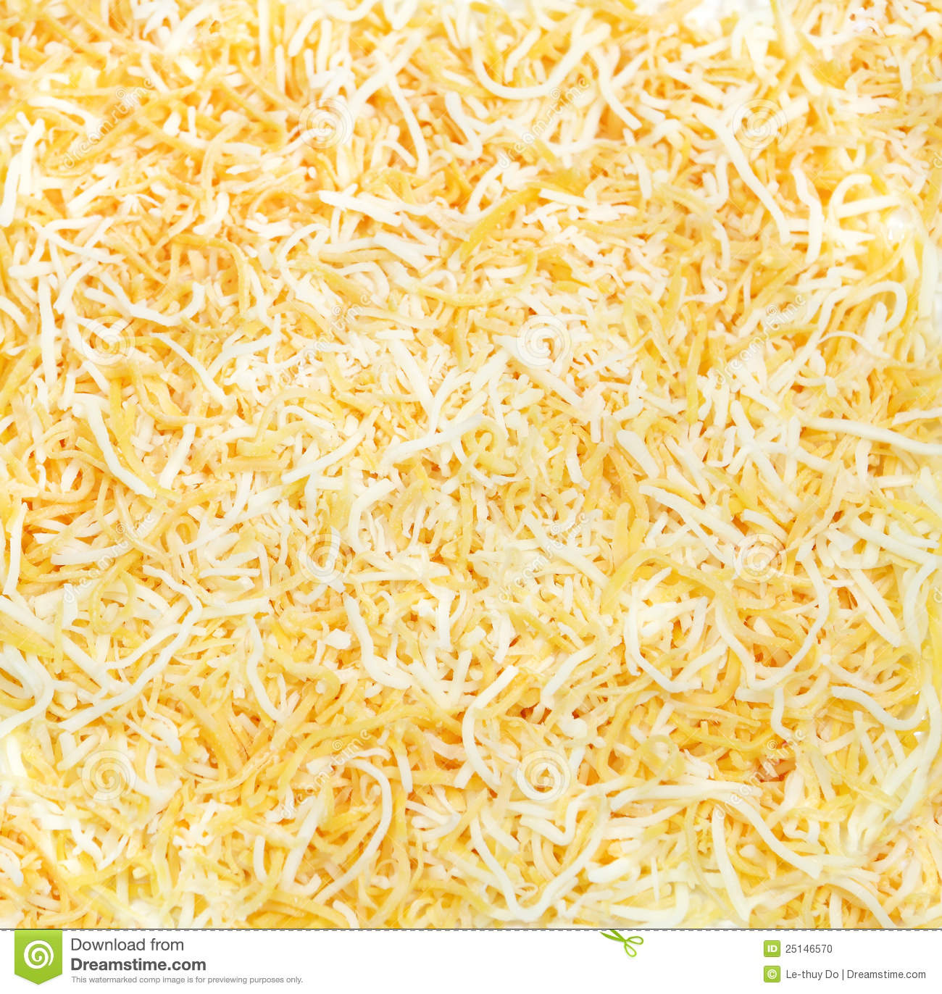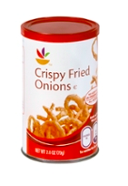
8. Cover with aluminum foil. Bake for 35 minutes. Eat.
