What’s For Dinner: Lasagna Alfredo
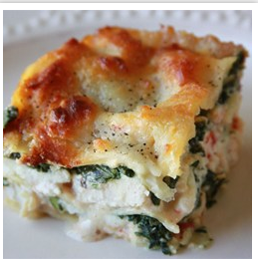
1. Heat oven to 350 degrees.
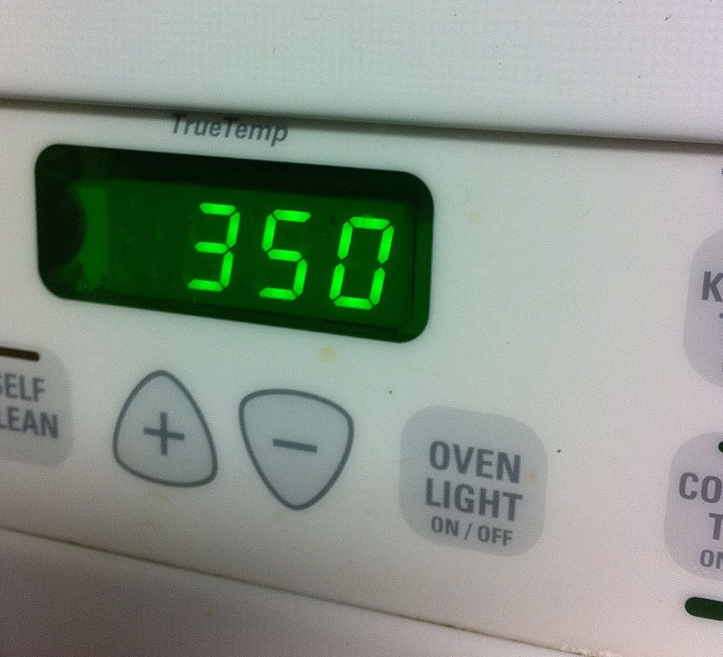
2. Combine chicken and ½ jar of light alfredo sauce into bowl #1. Stir.
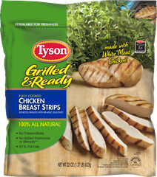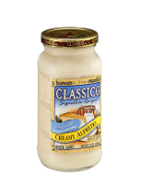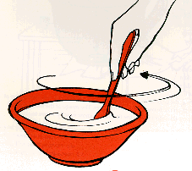
3. Combine part skim ricotta and thawed spinach in bowl #2. Stir.
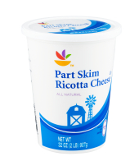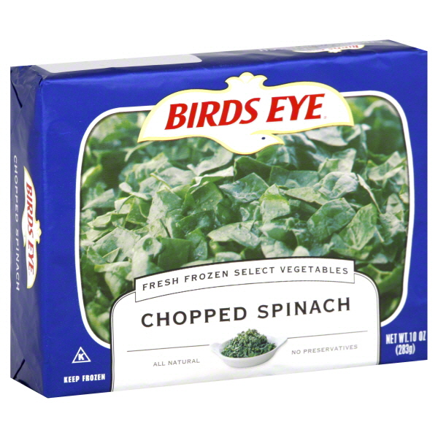
4. Spray a baking dish with oil. Place one layer of lasagna noodles across pan. (Lasagna noodles are oven ready and do not need to be boiled)
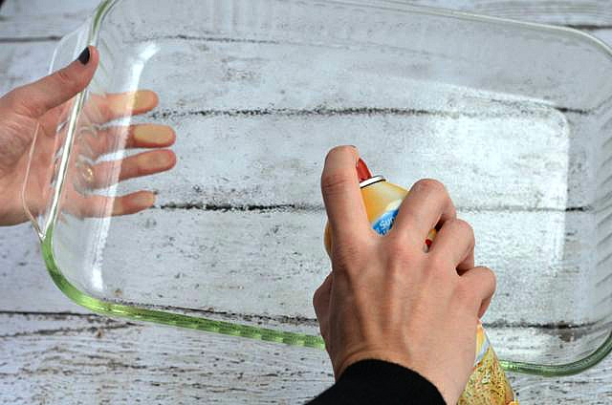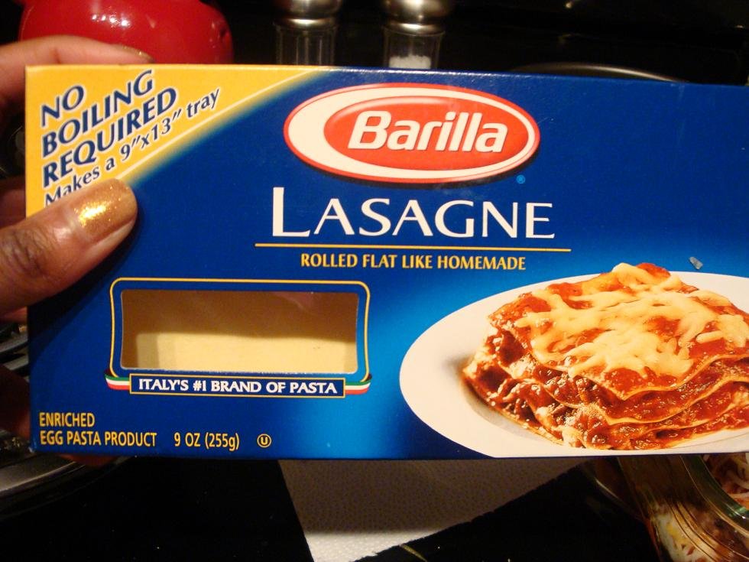

5. Add chicken mixture from bowl #1 to pan.
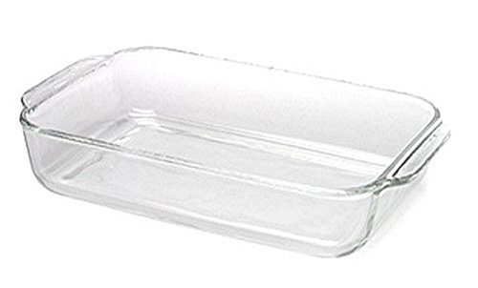
6. Spread ingredients in bowl #2 across pan.
7. Top with another layer of noodles.
8. Top with the rest of the light alfredo sauce and reduced fat mozzarella cheese.
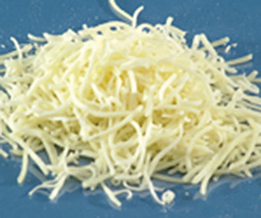
9. Cover with aluminum foil and bake for 50 minutes. Remove foil for the last 5 minutes.
