BAKED SALMON RECIPE

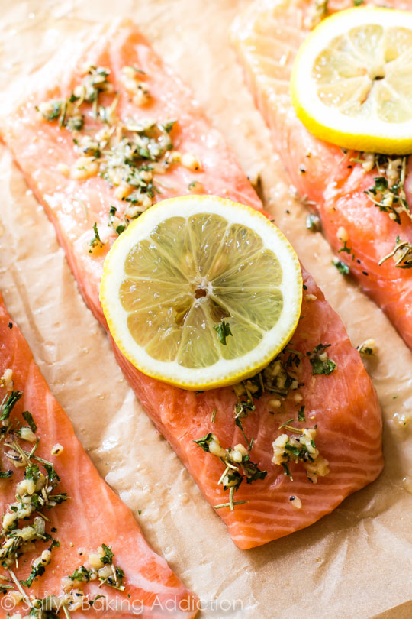

INGREDIENTS
  - salmon fillet, 1 1/4 pounds

  - teaspoon salt

  - 1 lemon

  - Italian seasoning : or Parsley, thyme, & dill

  - Garlic powder

  - Onion powder

  - Olive oil

DIRECTIONS
- Heat oven to 400ºF. Spray shallow baking pan with cooking spray. Pat salmon dry with paper towel. Place salmon, skin side down, in pan; brush with 1 tablespoon of the olive oil. Sprinkle with salt.
- Cut Lemon in half, and squeeze half of the lemon over the fresh. Then sprinkle on herb seasoning mix.
- Bake covered 15mins and uncovered for the last 5-10 minutes or until salmon in tender.. Serve immediately.

