What’s For Dinner: Chicken Pot Pie
Supporting Materials
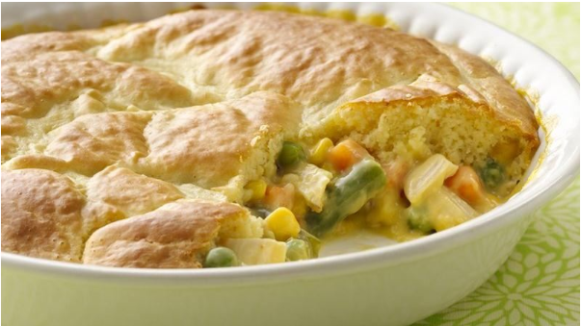

Original Recipe:
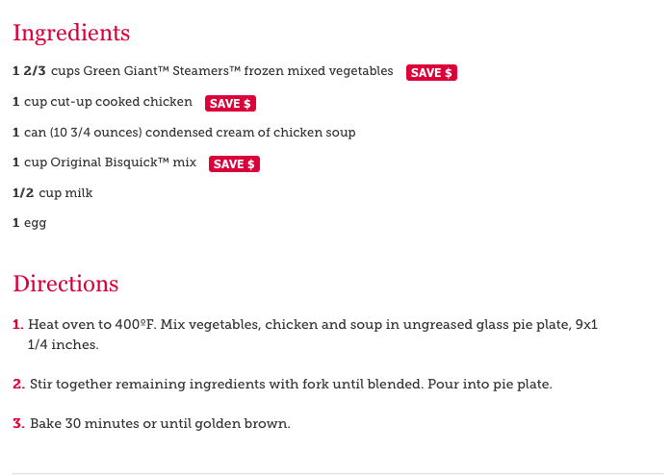

Equipment Needed:

- oven
- scissors (to open frozen vegetables)
- glass pie pan
- spoon, fork
- bowl

Notes:.
- Some individuals will have difficulty mixing the Bisquick with egg and milk; hand-over-hand assistance may be necessary.
- If a round pie pan is not available, use a square baking pan.
- Some individuals will have difficulty opening vegetables with scissors; this might have to be done for them or with them.

