What’s For Dinner: Barbeque Chicken Casserole
Supporting Materials

Original Recipe
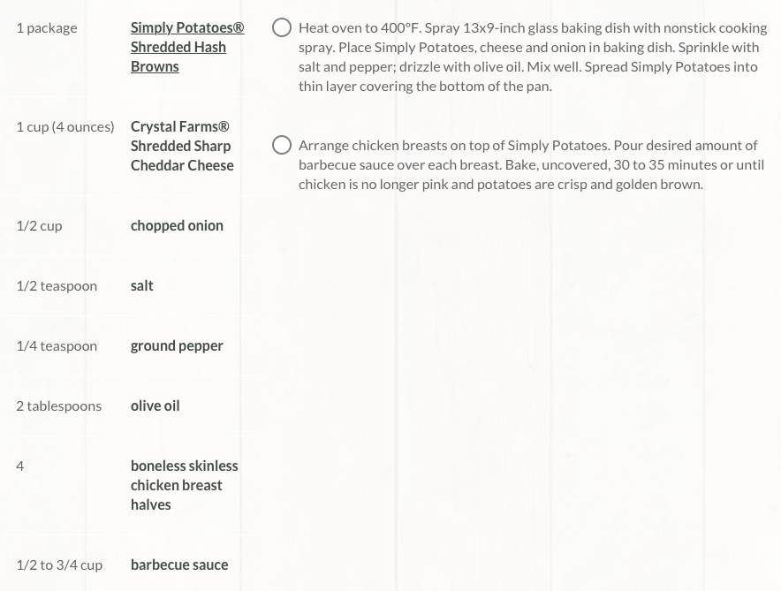

Equipment Needed:

- Oven
- Spoon (to stir and to spread barbeque sauce)
- scissors (to open potatoes and cheese)
- 2 quart baking pan
- spray oil

Notes:

- Some individuals will have difficulty holding the spray nozzle down when greasing the pan; use hand-over-hand to help them learn the motion.
- Spreading the potatoes and cheese will be difficult for some individuals; help them with hand-over-hand.
- Some individuals will struggle to brush the chicken with barbeque sauce; they may require hand-over-hand or visual cues.

