What’s for Dinner?: Chicken Pot Pie

If you don’t have a round pie
pan, use a sall, square baking pan.
1. Heat oven to 400 degrees.
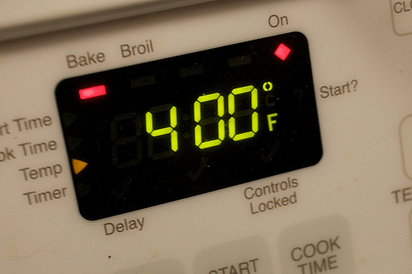
2. Put package of mixed vegetables and package of cooked chicken in bowl #1.
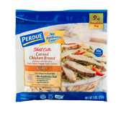
3. Add cream of chicken soup to bowl. Mix well.

4. In a separate bowl (bowl #2), add 1 cup of Bisquick flour, box of milk and 1 egg. Mix well.
5. Pour the chicken mixture (bowl #1) into a pie shell.
6. Cover the chicken/vegetable mixture with the Bisquick mixture (bowl #2).
7. Bake 35 minutes in oven, uncovered, until top is brown.

