What’s For Dinner: Chicken Pot Pie
Shopping List:

AMOUNT | ITEM
1 | 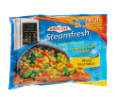  12 oz. bag mixed vegetables
1 | 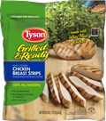  package cooked chicken
1 | 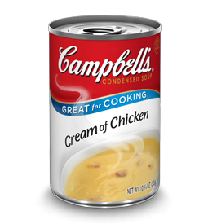  can light cream of chicken soup
2 | cups of Heart Smart Bisquick
2 | eggs
1 | 8 oz box of milk

