What’s For Dinner: Chicken Parmesan Casserole
Supporting Materials
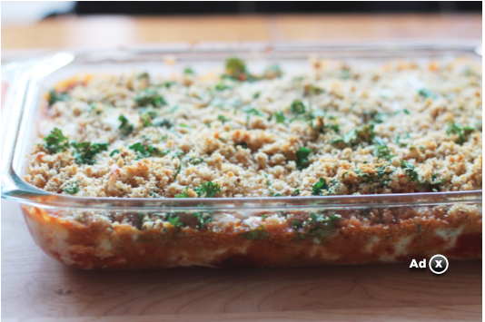
Original Recipe:

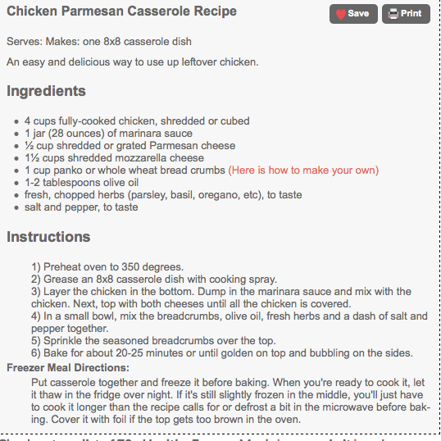

Equipment Needed:

- Oven
- Scissors to open packages
- 2 quart baking pan
- spoon
- disposable gloves (to handle chicken)

Notes:.
- Some individuals will have difficulty opening packages with scissors; this might have to be done for them or with them.
- It is important that gloves be worn while handling meat.
- Some individuals will have difficulty holding the spray nozzle down when greasing the pan and coating the top of the casserole; use hand-over-hand to help them learn the motion.
- It might be difficult for the individual to stir ingredients within the pan; assistance may be required.

