What’s For Dinner?: Baked Lemon Herb Salmon
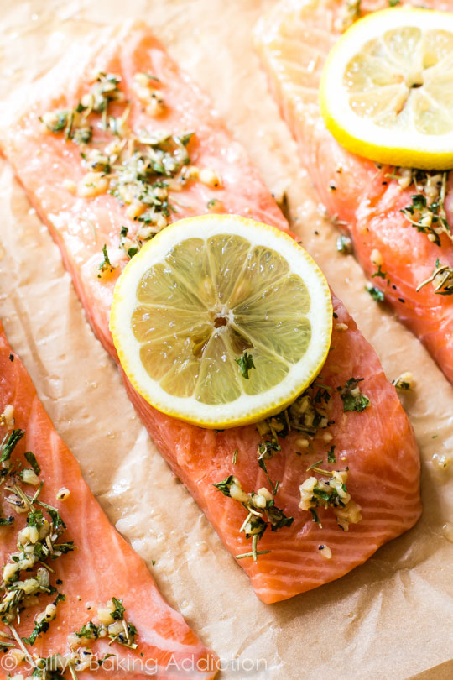
1. Heat oven to 400 degrees.
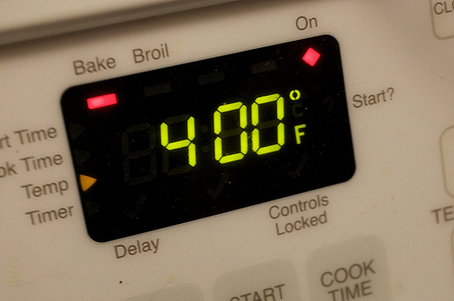
2. Cut lemon in half, and squeeze lemon juice over salmon.
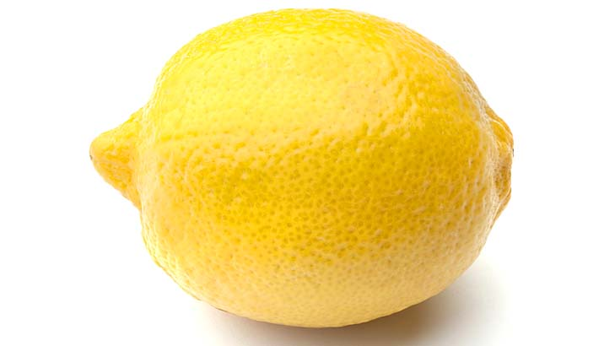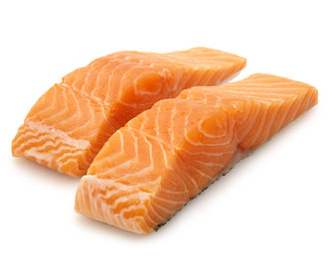
3. Put on gloves and toss the ingredients in the baking until fish is evenly coated in olive oil and seasoning.
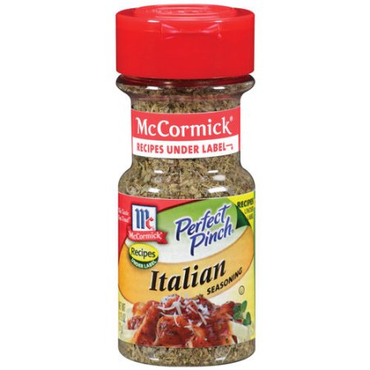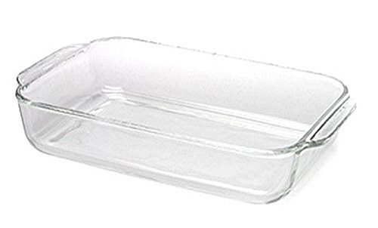
4. Slice the remaining half of the lemon into 3 slices and place over the fish in baking dish.
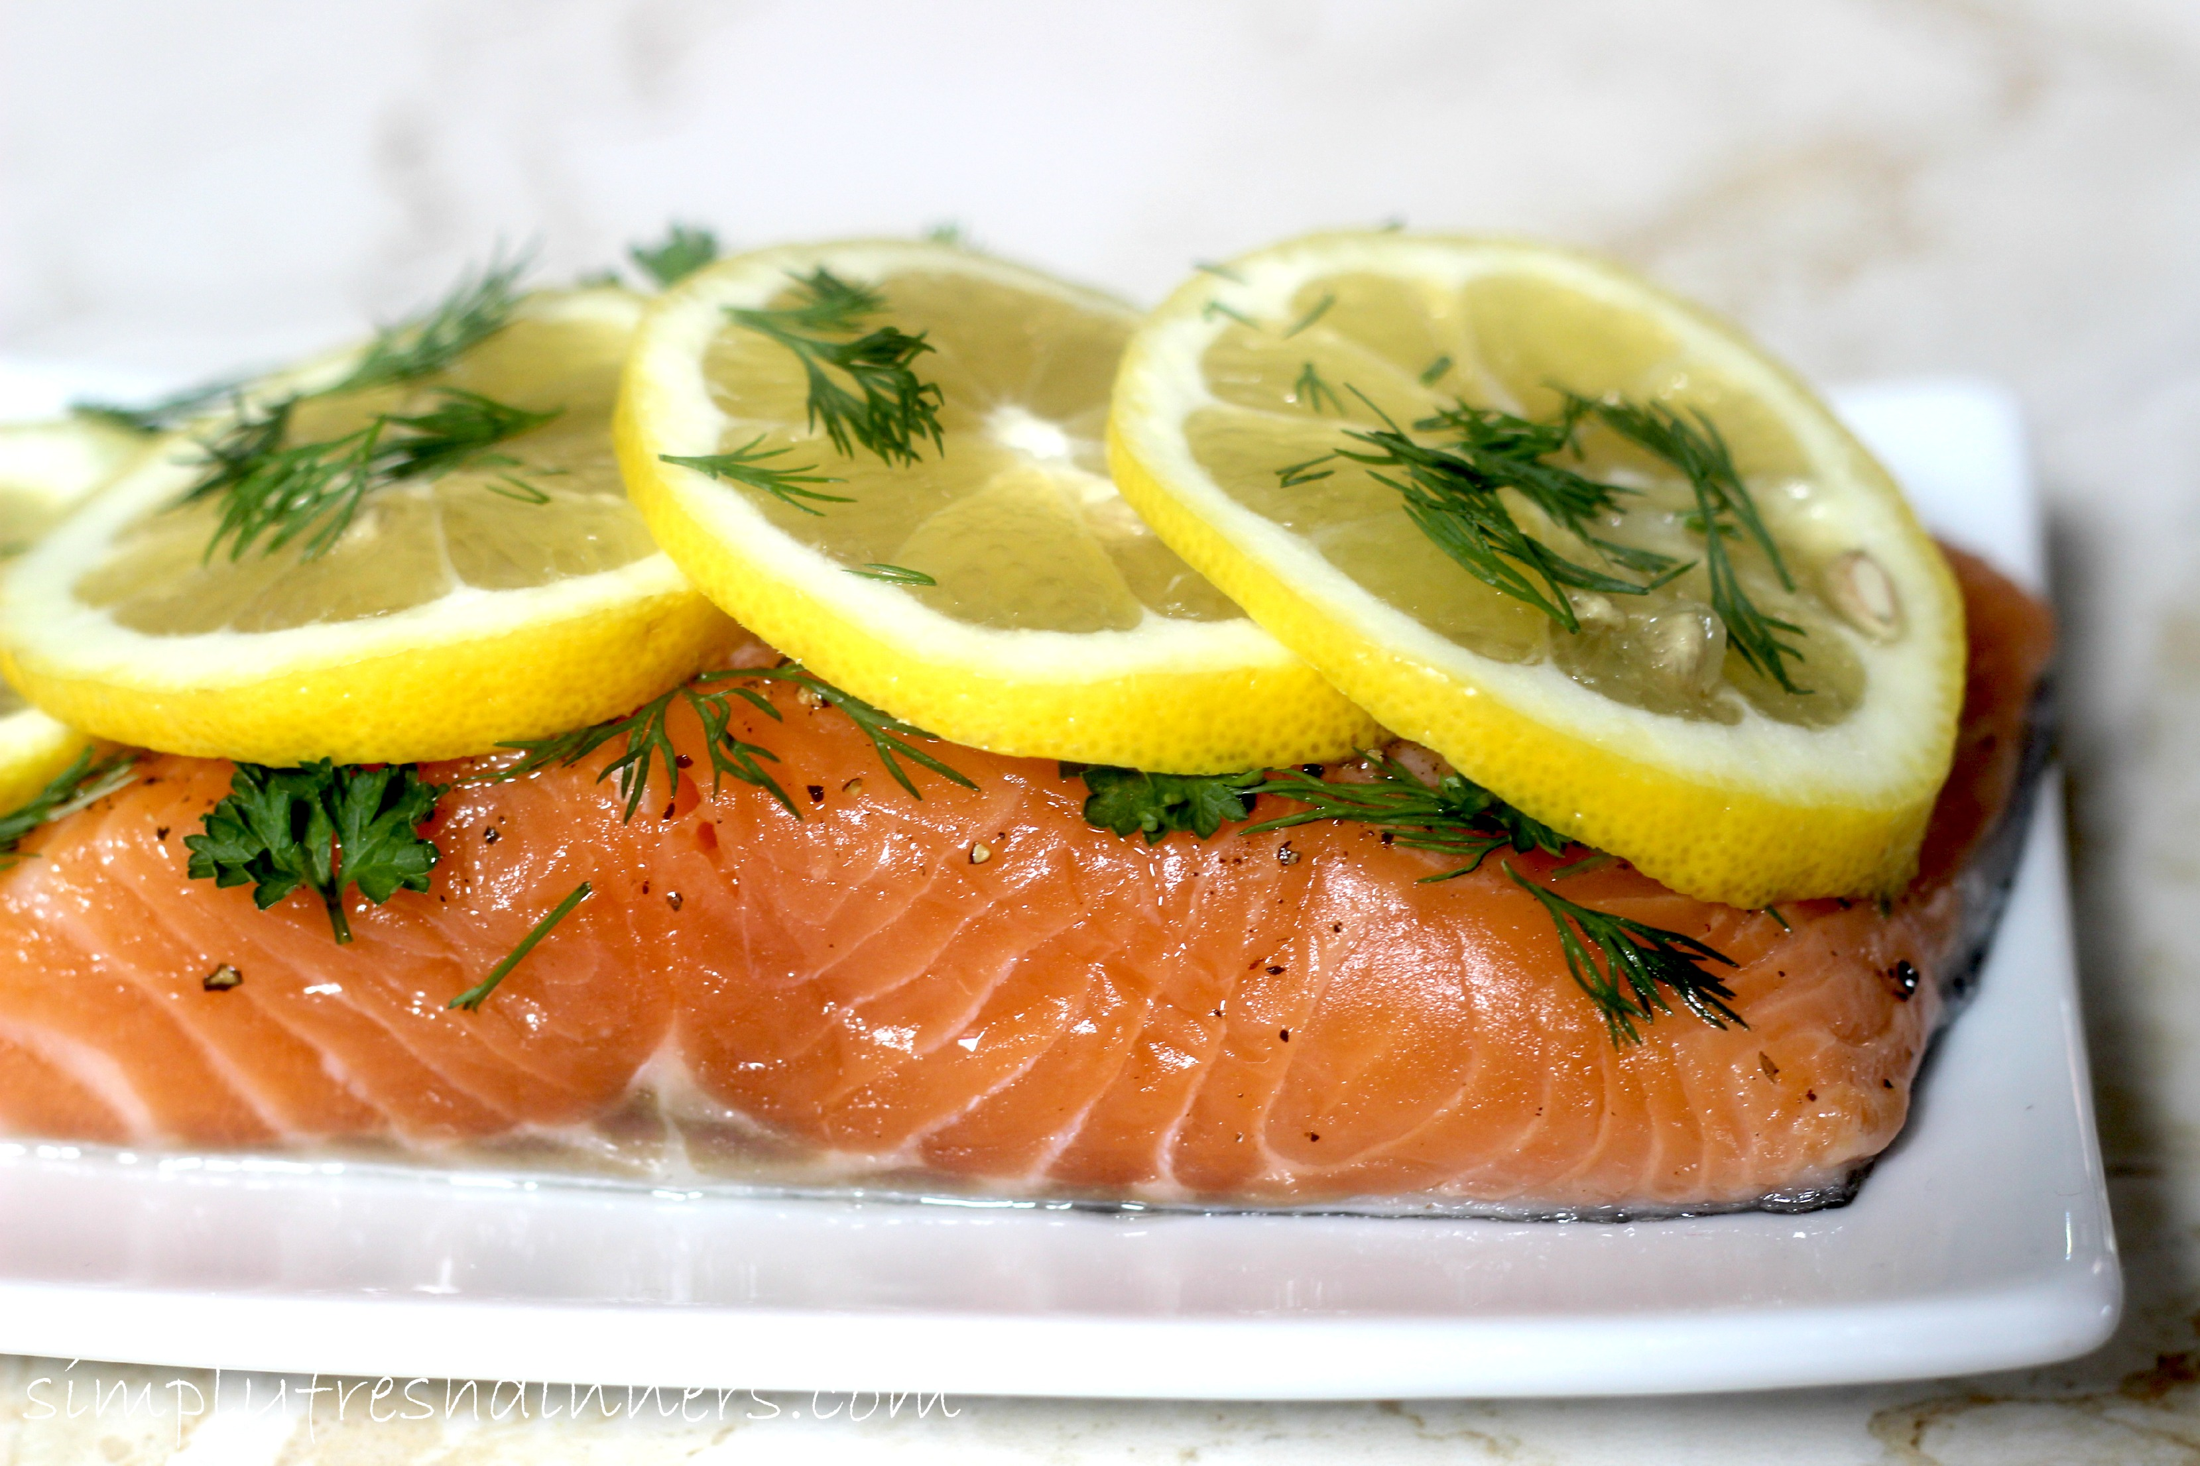

5. Cover with Aluminum foil, and place in the oven.

6. Bake covered for 15mins and the last 5-10 mins uncovered.
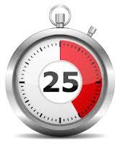
7. When done baking, cut salmon and serve with side dishes!!!

