What’s For Dinner: Bacon-Ranch Chicken
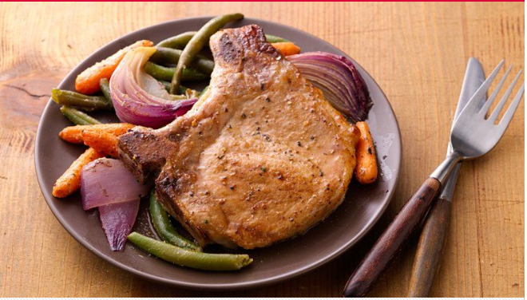
Shopping List:

AMOUNT | ITEM
1 | 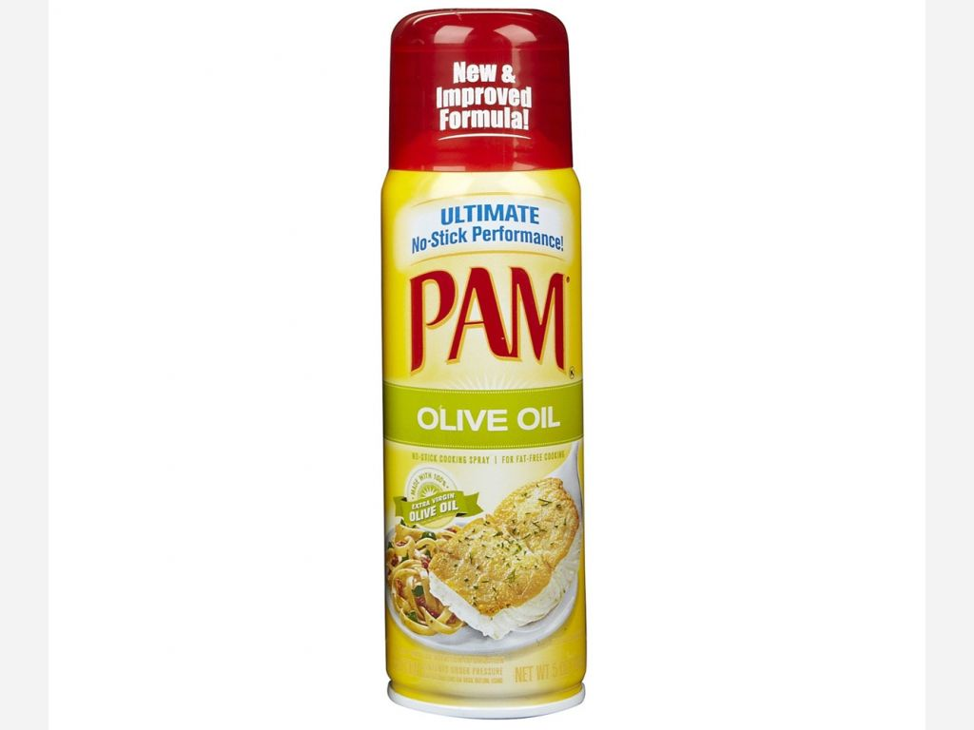  can oil spray
1 | 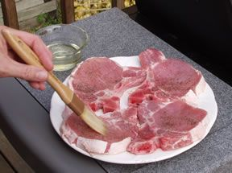  package pork chops (4 chops)
1 | 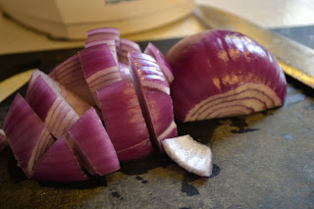  red onion
1 | 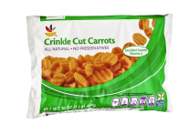  small package frozen carrots
1 | 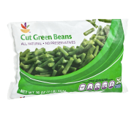  package cut green beans
1 | 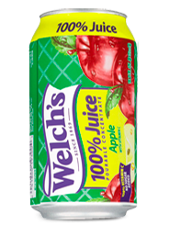  can apple juice concentrate
You will also need a small amount of:
Olive oil
Dijon Mustard
Marjoram spice
(see original recipe under supporting materials)

