**What’s For Dinner: Bacon-Ranch Chicken**

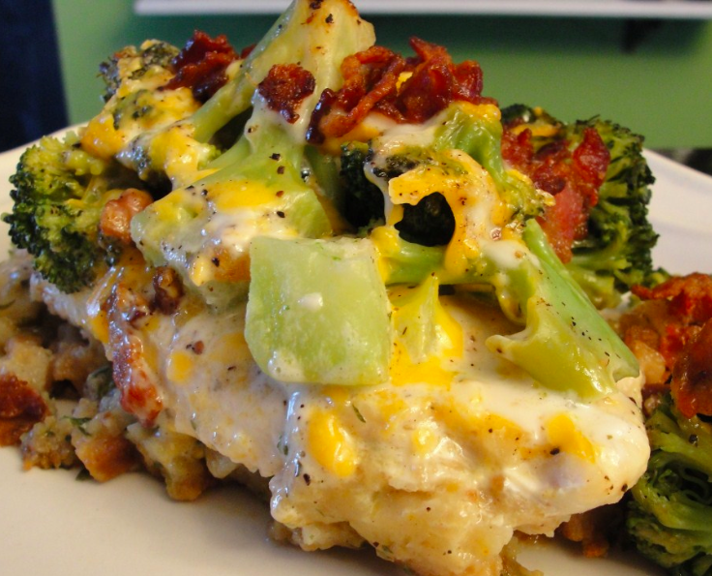

Shopping List:

|  |  |
| --- | --- |
| AMOUNT | ITEM |
| 1 | can oil spray |
| 1 | package chicken breasts (4 breasts) |
| 1 | package broccoli florets |
| 1 | bottle light ranch dressing |
| 1 | package cheese |
| 1 | bag crumbled bacon |