What’s For Dinner: Ham and Swiss Cheese Potato Bake
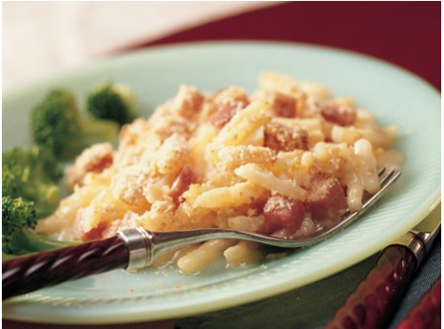
Shopping List:
AMOUNT | ITEM
1 | 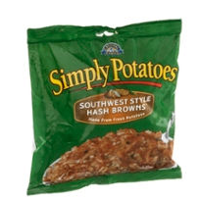  package hash brown potatoes
1 | 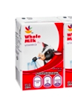  box (8 oz.) milk
1 | 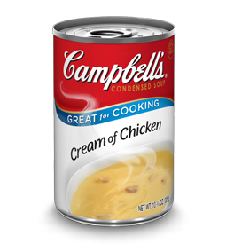  can Cream of Chicken soup
1 | 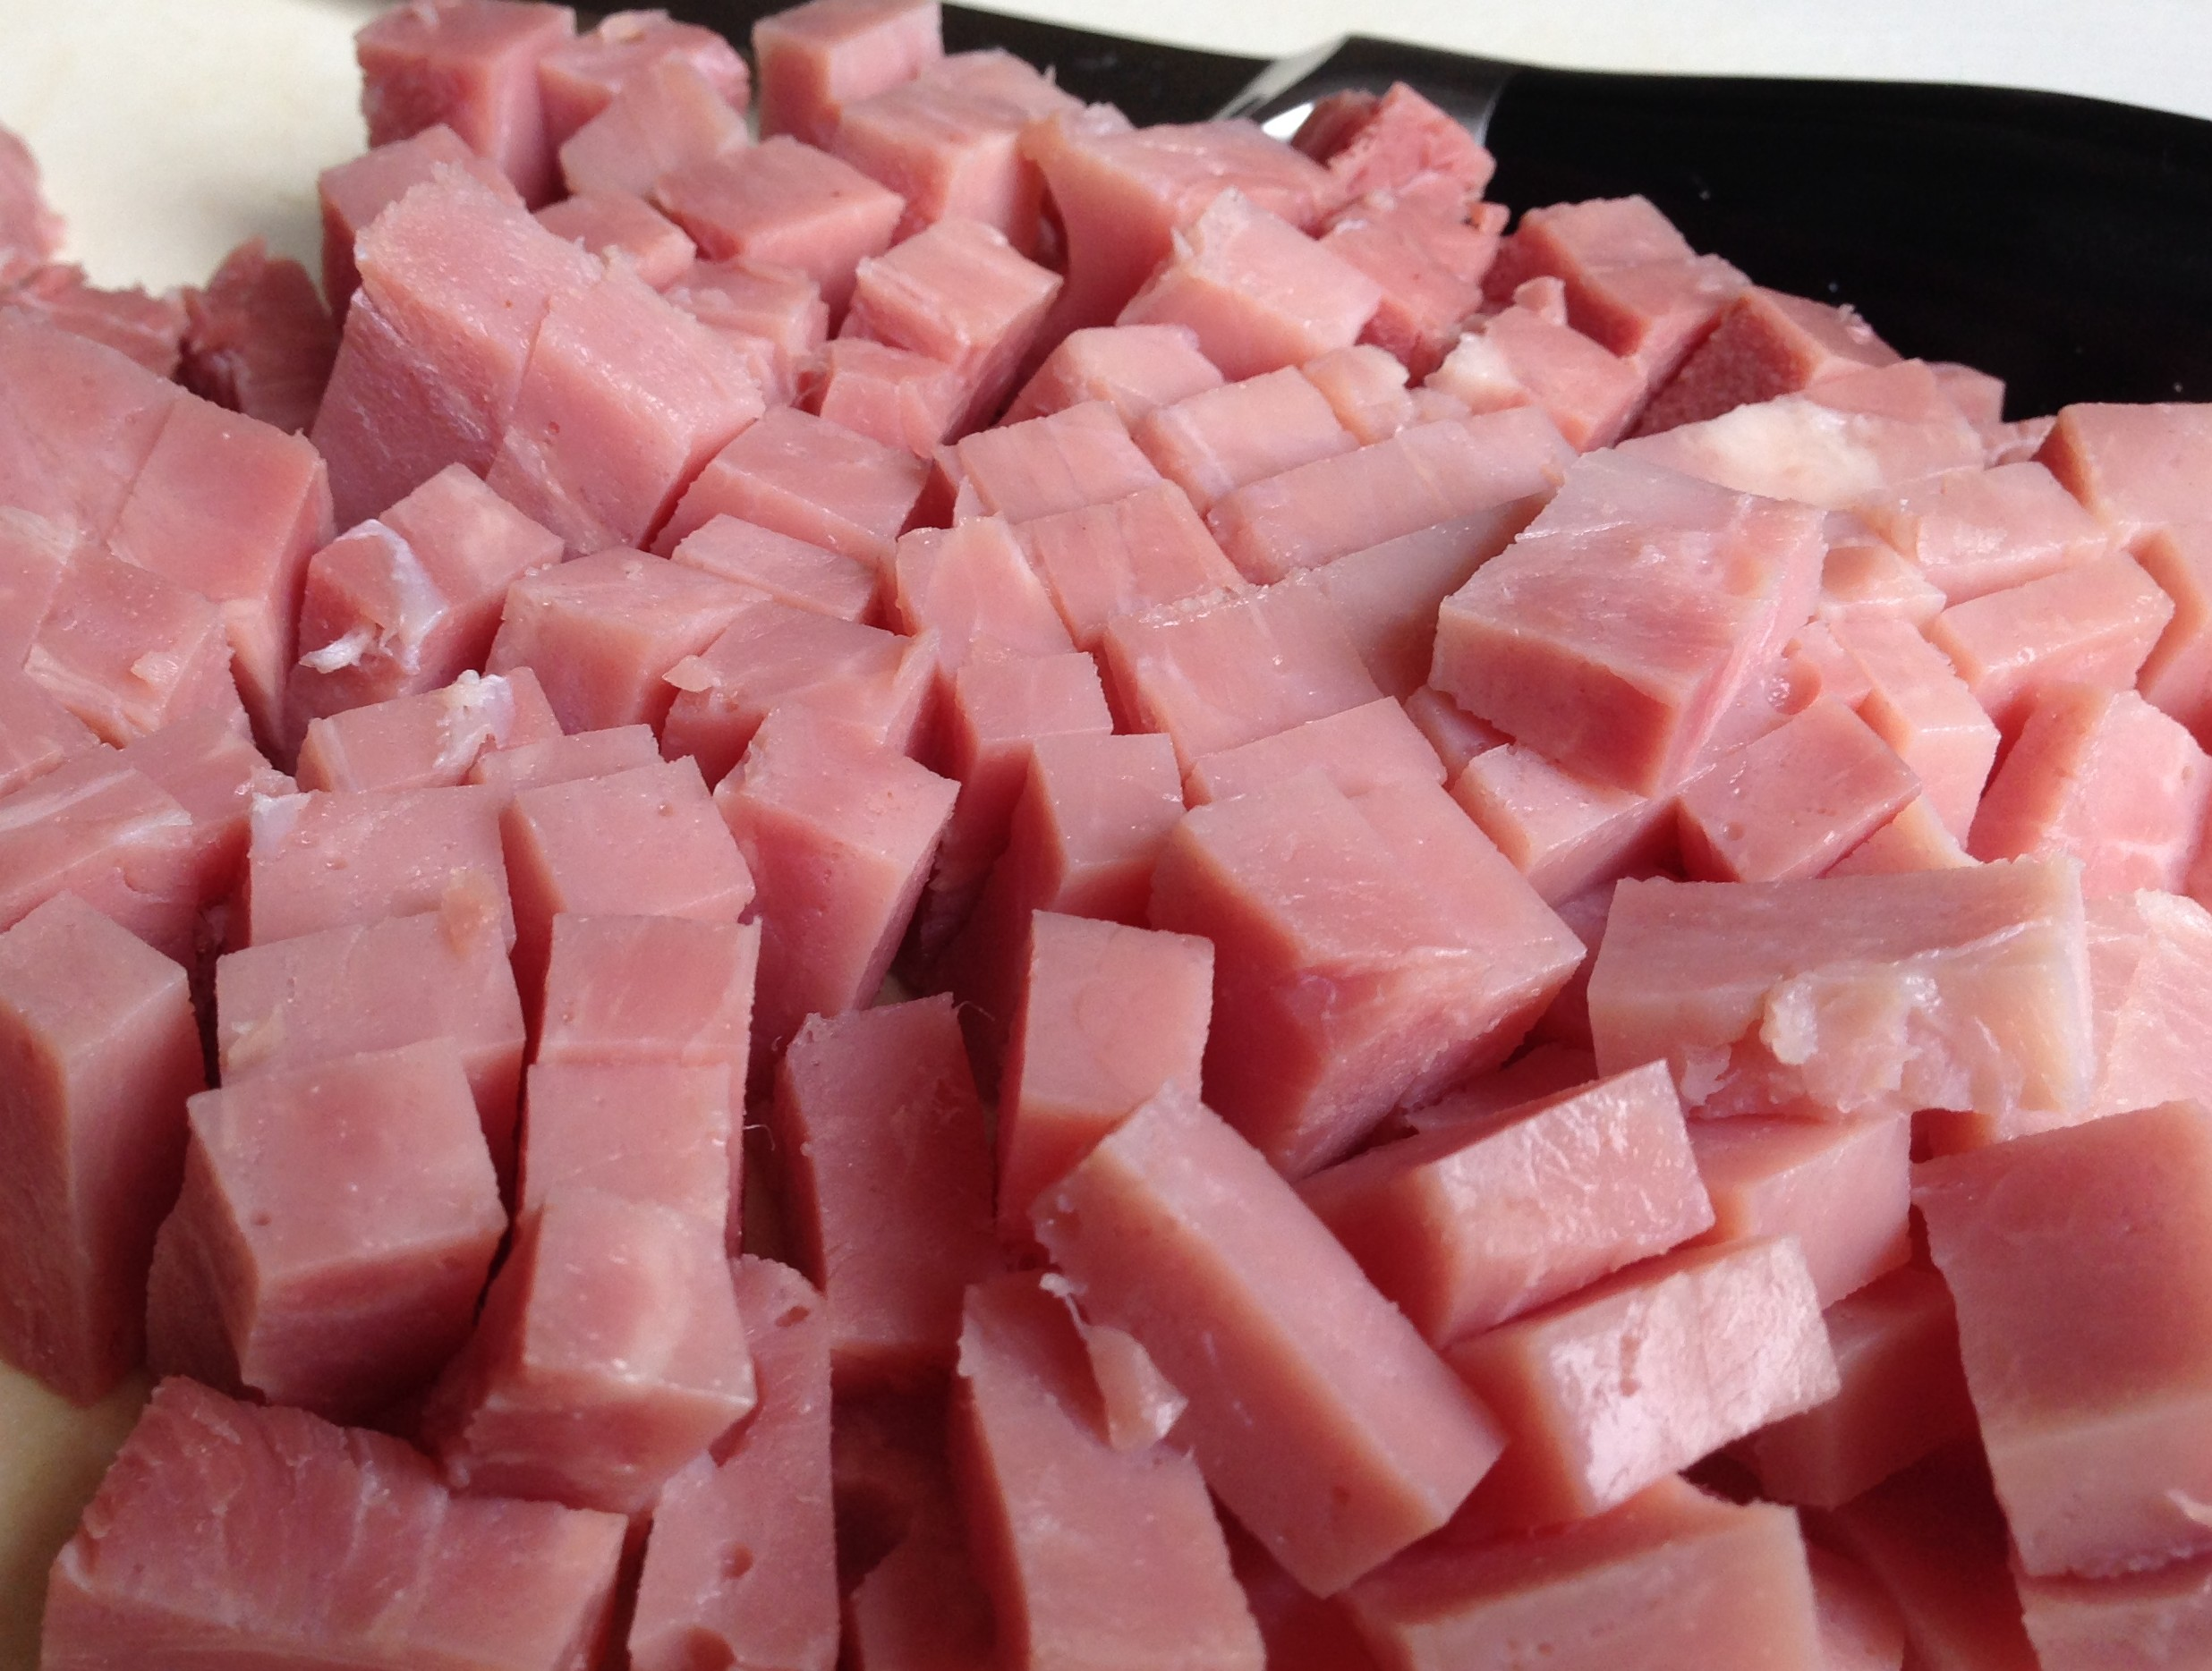  package cubed ham
1 | 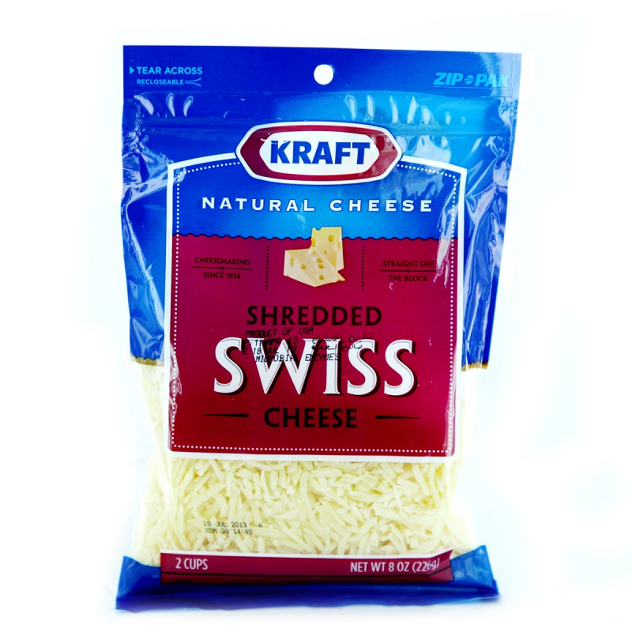  8 oz. package swiss cheese
1 | 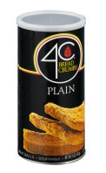  1 cup bread crumbs
1 | 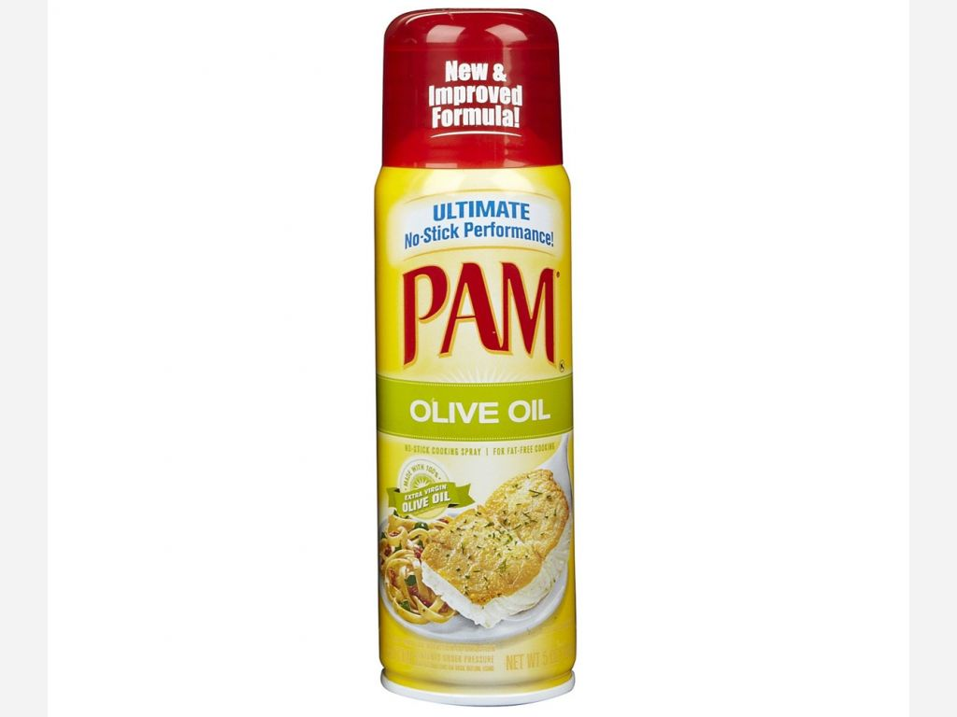  1 can spray oil

