**Dinner by Me: Breaded Pork Chops**



1. Preheat oven to 425 degrees. Line a baking sheet with aluminum foil. Spray baking sheet with oil.

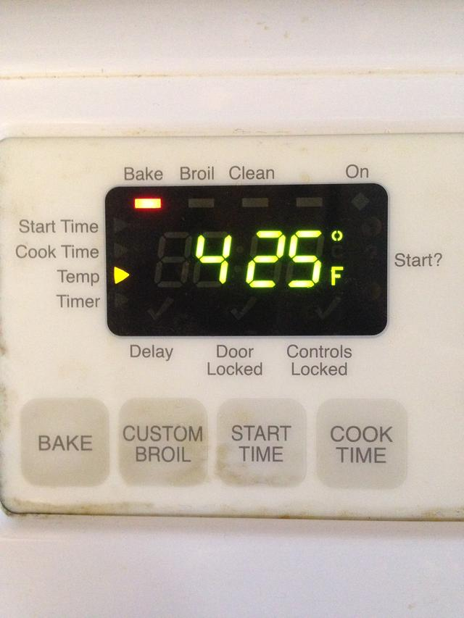  

1. Pour milk in bowl. Dip each pork chop in milk until completely wet.

 

1. Put each wet pork chop in baggie with crumbs and seasonings. Shake until fully coated.

 

1. Place coated pork chops on greased baking sheet.



5. Bake for approximately 25 minutes, or until pork chop is cooked thoroughly.

