What’s For Dinner: One Pot Taco Casserole
Supporting Materials

Original Recipe:
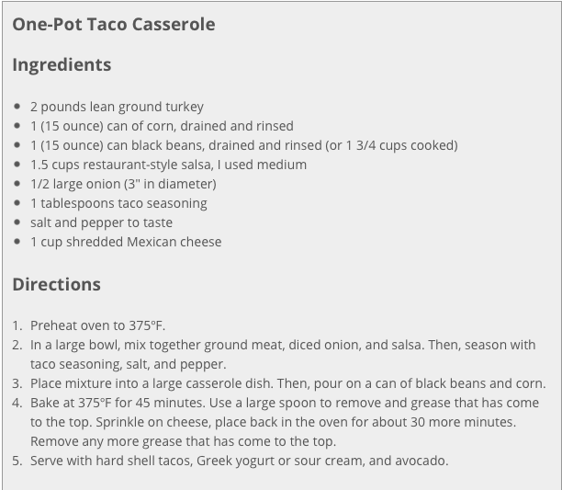

Equipment Needed:

- scissors (to open onions and taco seasoning)
- baking dish
- large bowl
- spoon
- 1 tablespoon
- Disposable gloves (to handle raw meat)

Notes:

- It is best to buy the cheese already shredded for ease of production. A variety of different cheeses can be used with this recipe.
- Some individuals will have difficulty with scissors; this might have to be done for them or with them.
- When possible, choose snap-off cans unless the individual is capable of using a can-opener.
- It is important that gloves be worn while handling raw meat, and then discarded.

