What’s For Dinner: Rice Chicken Wraps
Supporting Materials
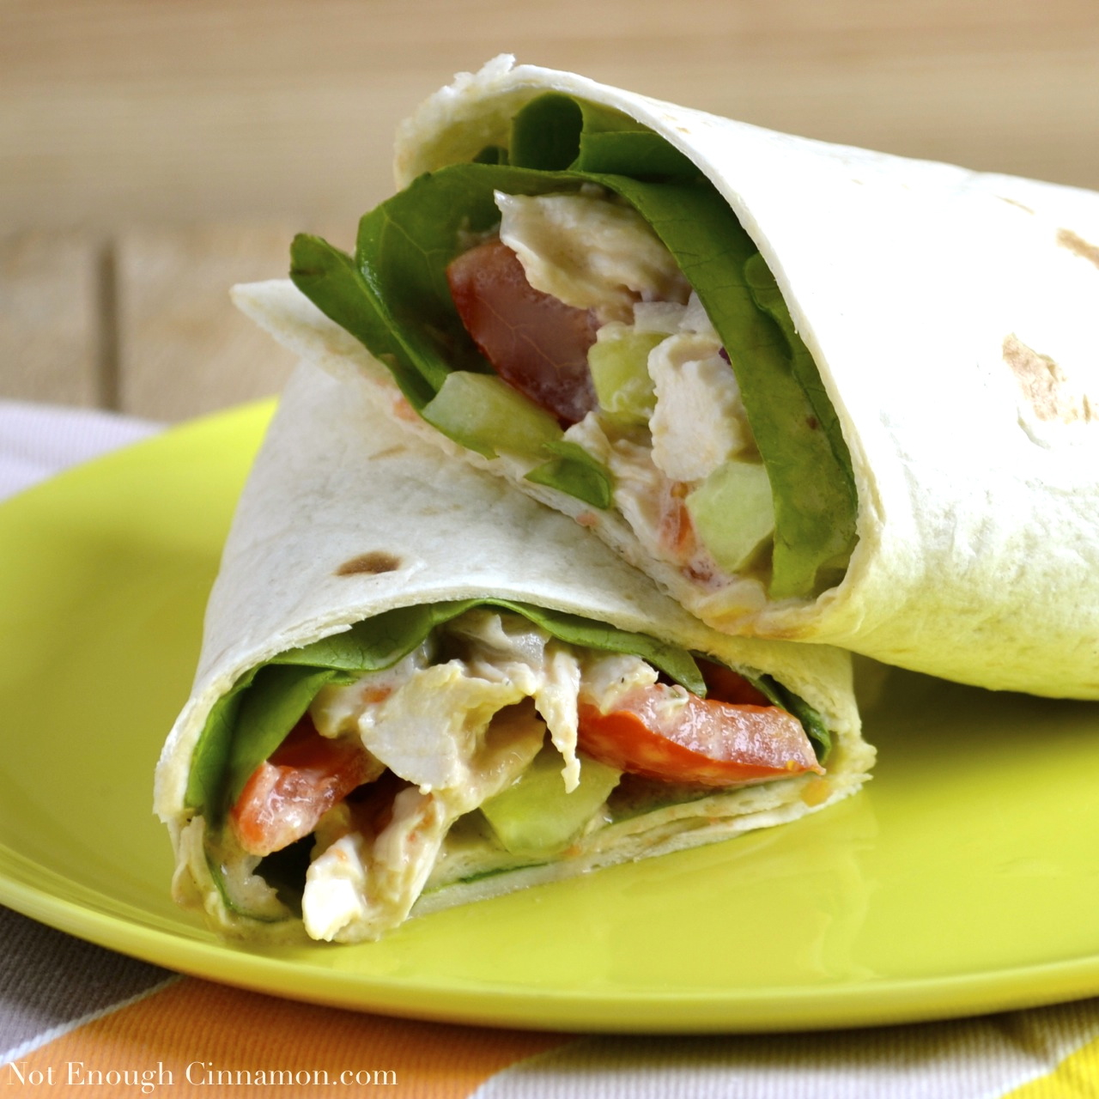

Original Recipe:

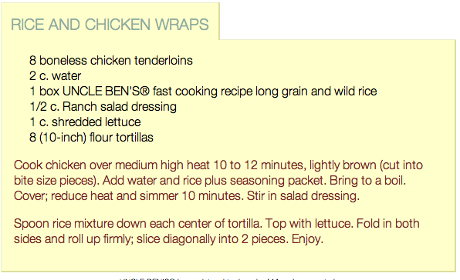

Equipment Needed:

- microwave
- scissors (to open tortillas, rice mix)
- bowl
- spoon
- 1 Cup Measuring cup
- knife to cut tomato

Notes:.
- Some individuals will have difficulty opening the rice and tortillas with scissors; this might have to be done for them or with them.
- Some individuals will have difficulty in understanding how to use only 1 cup of the dressing. Let them know that they can also estimate by using ½ of the bottle. Talk them through this process and offer visual clues.
- Some individuals will have difficulty with spreading the ingredients over the tortilla; this can often result in uneven distribution. Help them move slowly throw this procedure and emphasize even distribution.

