What’s For Dinner: Oven Fried Chicken
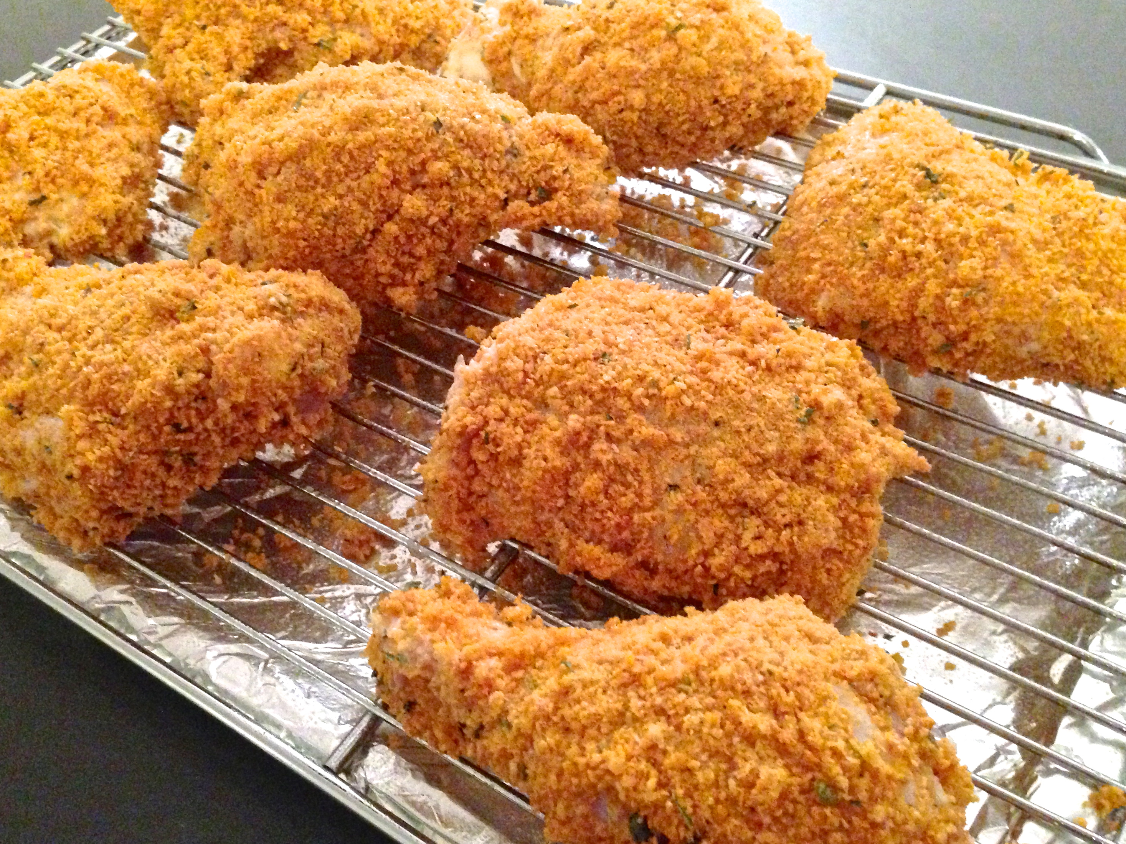
1. Heat oven to 350 degrees.
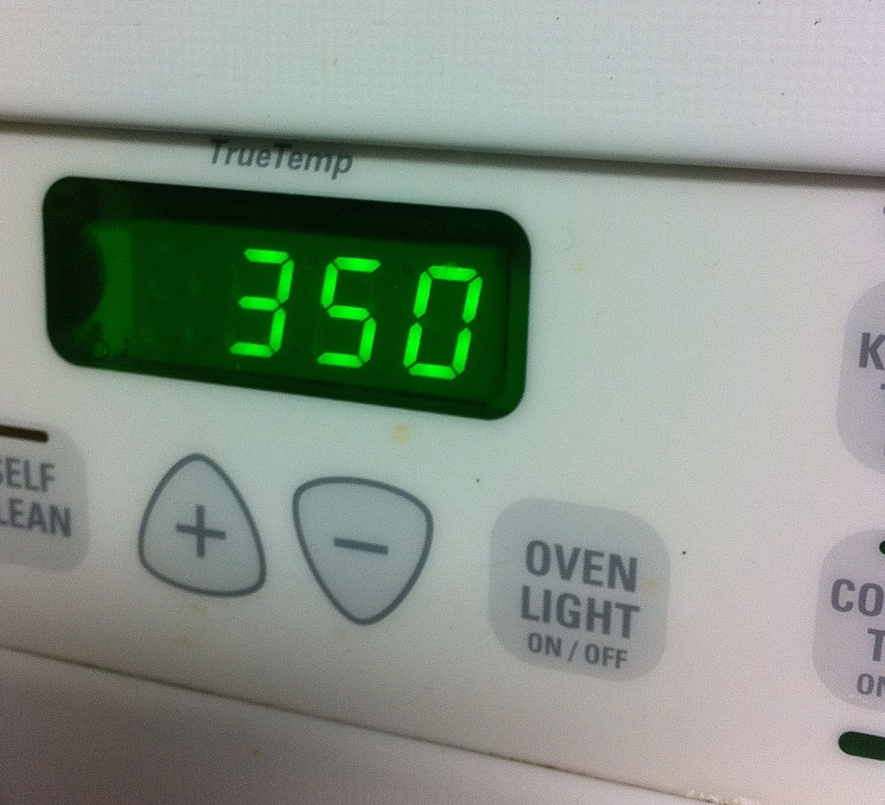
2. Line baking sheet with aluminum foil and spray with oil.
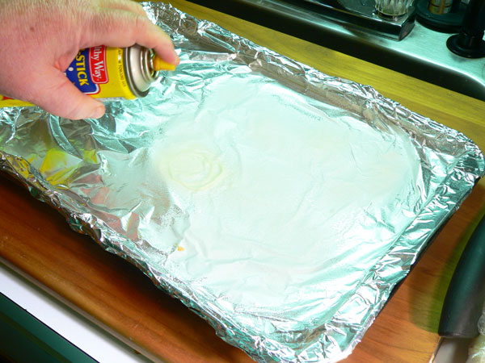
3. Open buttermilk and pour into bowl
4. Put on gloves.
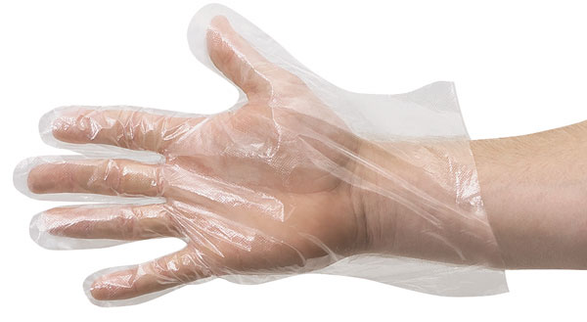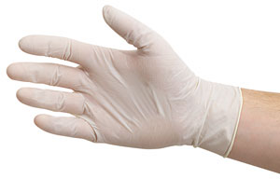

5. Dip each piece of chicken into buttermilk in bowl.
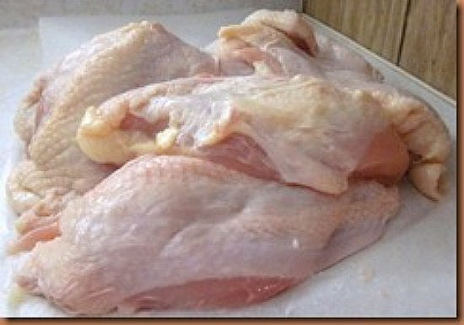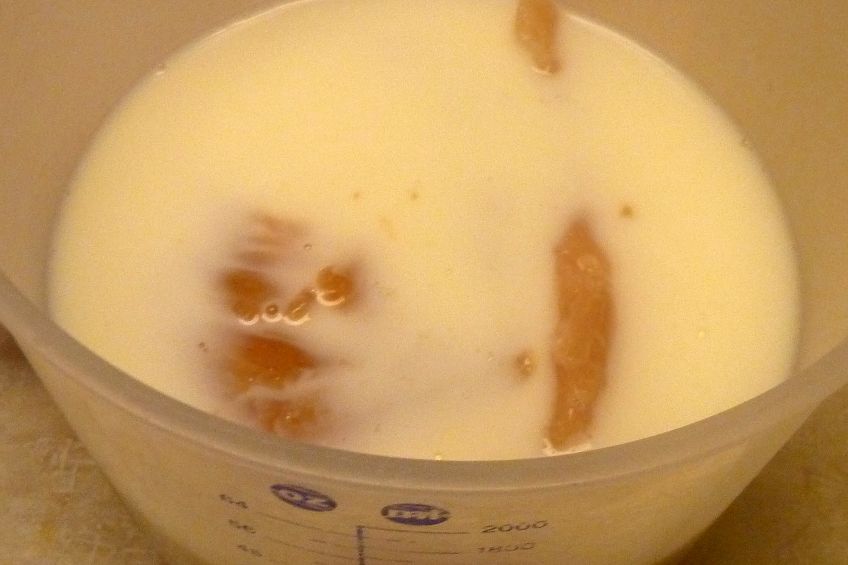

6. When chicken is wet, dip in bag of
crushed cornflakes and coat well.
7. Put chicken on greased baking sheet.
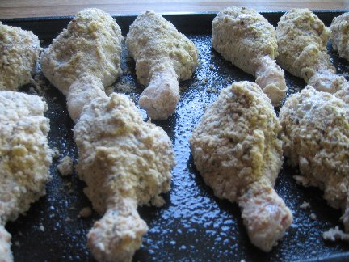
8. Bake 1 hour, until golden brown. Eat.

