What’s For Dinner: Oven Fried Chicken
Supporting Materials
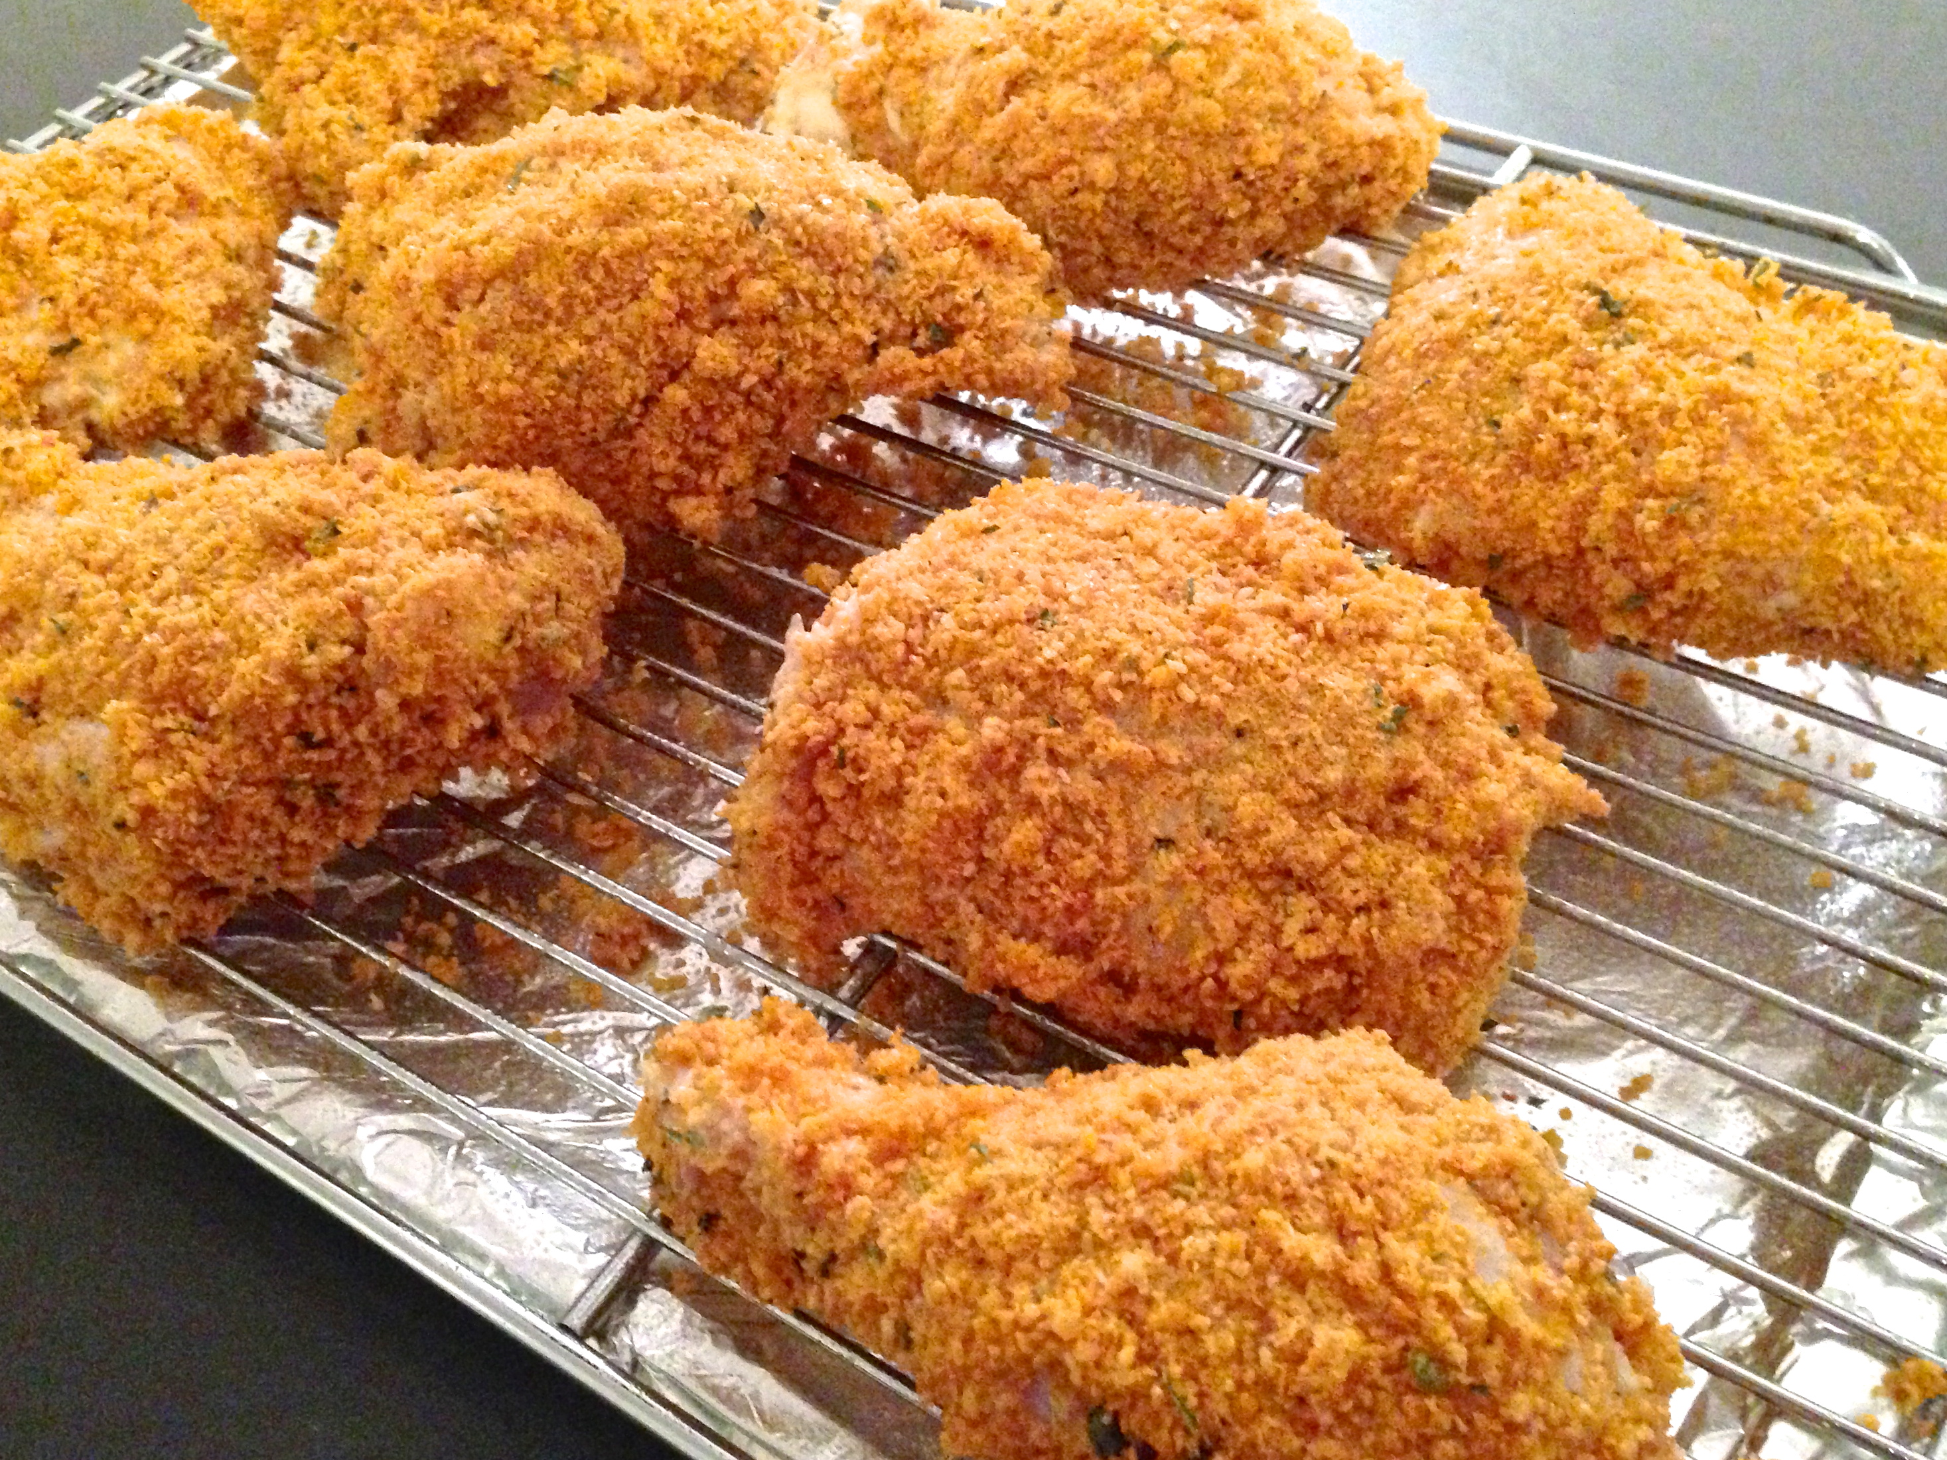

Oven Fried Chicken Original Recipe:
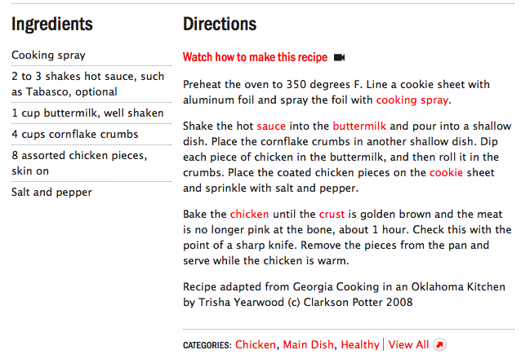

Equipment Needed:
- oven
- baking sheet
- spray oil
- bowl
- Disposable gloves (to handle raw meat)
- baggie (for crushed corn flakes)

Notes:

- This recipe requires no measurement so independence should be encouraged.
- Gloves should be worn as raw meat is involved.
- This is a very tactile recipe to prepare, so some sensory defensive individuals may prefer to use tongs to dip chicken.
- This recipe can also be made with boneless chicken breasts. If this is done, the cooking time should be reduced to approximately 45 minutes or until the chicken is cooked throughout.

