What’s For Dinner: Cheesy Chicken & Rice Casserole
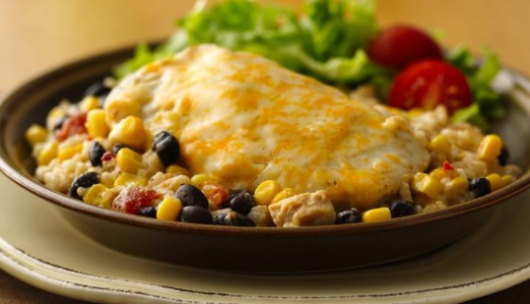

Shopping List:

AMOUNT | ITEM
1 | 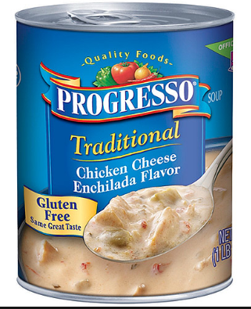  Progresso Enchilada Soup (can be light version as well)
1 | 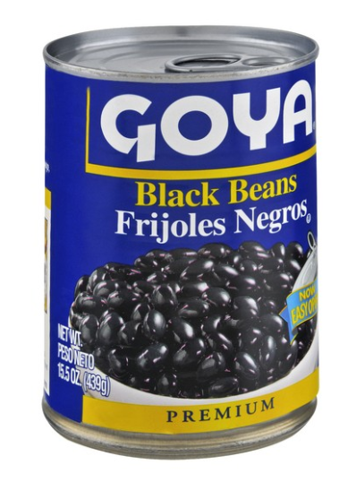  Black Beans (w/ tab top)
1 | 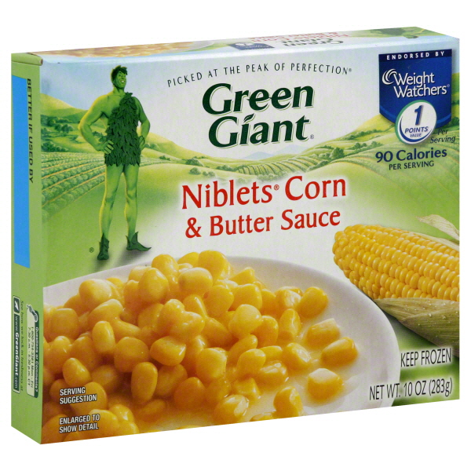  Corn Nibblets
1  small bag | 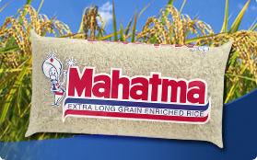  Long grain wild rice
1  small bag | 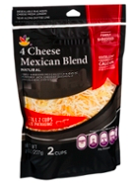  Shredded Cheese
1 | 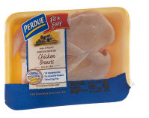  Chicken Breasts
1  teaspoon | 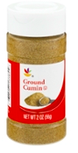  Cumin

